QuaSAR Quantitative Statistics

QuaSAR is a program that aids in the Quantitative Statistical Analysis of Reaction Monitoring Experiments. It was designed to quickly and easily convert processed SRM/MRM-MS data into calibration curves, determine limits of detection and quantification, calculate mean and coefficient of variation for all transitions of each peptide in a set of samples, as well as determine the peptide analyte concentration in unknown samples. The resulting output files, consisting of *.csv tables and *.pdf figures, can be readily used for further statistical analyses or reported as output for reports or publications.

In order to use QuaSAR with Skyline, it must be installed through the Skyline external tools framework. Furthermore, QuaSAR requires the use of custom annotations in Skyline. This tutorial covers the installation of QuaSAR, how to input data for custom annotations, and how to run the tool itself.

# Getting Started

To start this tutorial, download the following ZIP file:

<https://skyline.gs.washington.edu/tutorials/QuaSARTutorial.zip>

Extract the files in it to a folder on your computer, like:

C:\Users\brendanx\Documents

This will create a new folder:

C:\Users\brendanx\Documents\QuaSARTutorial

The zip file contains the following files:

QuaSAR_Tutorial.sky: A Skyline document containing sample data for QuaSAR.  
QuaSAR_Tutorial.skyd: Contains extracted chromatogram data for the Skyline document.

QuaSAR-1_0.zip: The QuaSAR external tool.

Open the provided file QuaSAR_Tutorial.sky in Skyline.

# Installing QuaSAR as an External Tool

The Skyline external tools framework supports the direct integration of statistical analysis tools that process the data in a Skyline document.

To add QuaSAR as an external tool, perform the following steps:

* On the **Tools** menu, click **External Tools** to bring up the **External Tools** form.

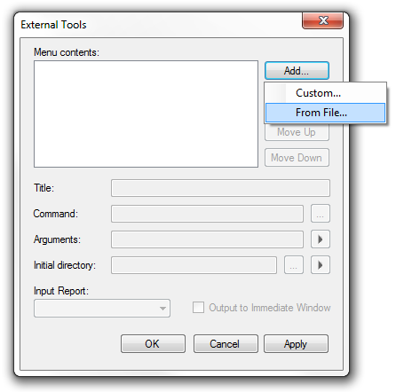

Note: Your External Tools menu may already contain some Tools

* Click the **Add** button, and select **From File** from the context menu.
* Navigate to the location of the QuaSAR-1_0.zip file in the folder you created and select it.
* Click the **Open** button.

Skyline will now guide you through the process of installing QuaSAR as an external tool. This may require you to install the R statistical programming environment, as well as a number of R packages which are used by QuaSAR to perform its statistical analysis. For example, if you do not have the appropriate version of R installed, the following form will be displayed:

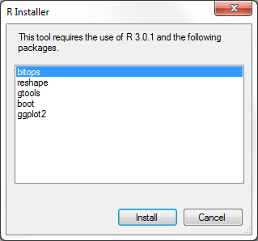

Note: This form may look slightly different as the packages might

change and if you already have R 3.0.1 installed.

To complete the installation, performing the following steps:

* On the **R Installer** form, click **Install**.
* If you do not have the specified version of R installed on your machine, wait for R to download. When the download is completed, you will be asked to install R onto your computer. Complete the R installation process by working through the R installer wizard.
* Once the R installation is completed, Skyline will download and install the necessary R packages for QuaSAR. When prompted to run the “SkylineProcessRunner”, click the **Yes** button to install packages.

Once the installation is complete, the QuaSAR tool will appear in the **External Tools** form:

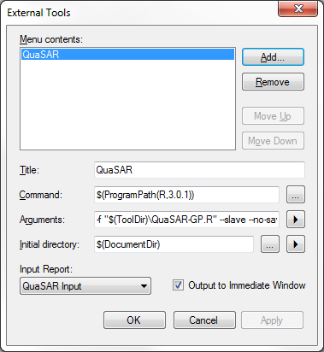

* Click the **OK** button on the **External Tools** form.

# Annotating samples with concentration information

Skyline allows you to associate additional information with the replicates in the document by defining custom annotations. When QuaSAR was installed, it should have defined three custom annotations: **SampleGroup, Concentration** and **IS Spike.**

The **Annotation Settings** form will show the list of the annotations that have been defined.

To view the Annotation Settings form, perform the following step:

* On the **Settings** menu, click **Annotations**.

You must check the checkboxes in the list in order to be able to use these annotations in your current Skyline document. The **Annotation Settings** form should look like the one shown below:

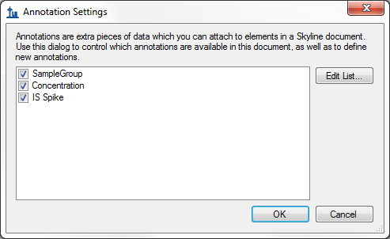

* Click the **OK** button.

Editing annotation values in Skyline is done using the Results Grid. To bring up the Results Grid do the following:

* On the **View** menu, click **Results Grid** (Alt-2).

The **Results Grid** will show you chromatogram peak areas and other measured results for the currently selected peptide, or transition. Select a protein to see only the replicate annotations.

Copy the values in the following tables and paste them into the results grid:

|  |  |  |
| --- | --- | --- |
| **SampleGroup** | **Concentration** | **IS Spike** |
| A | 0 | 10 |
| A | 0 | 10 |
| A | 0 | 10 |
| A | 0 | 10 |
| B | 0.001 | 10 |
| B | 0.001 | 10 |
| B | 0.001 | 10 |
| B | 0.001 | 10 |
| C | 0.004 | 10 |
| C | 0.004 | 10 |
| C | 0.004 | 10 |
| C | 0.004 | 10 |
| D | 0.018 | 10 |
| D | 0.018 | 10 |
| D | 0.018 | 10 |
| D | 0.018 | 10 |
| E | 0.075 | 10 |
| E | 0.075 | 10 |
| E | 0.075 | 10 |
| E | 0.075 | 10 |
| F | 0.316 | 10 |
| F | 0.316 | 10 |
| F | 0.316 | 10 |
| F | 0.316 | 10 |
| G | 1.33 | 10 |
| G | 1.33 | 10 |
| G | 1.33 | 10 |
| G | 1.33 | 10 |
| H | 5.62 | 10 |
| H | 5.62 | 10 |
| H | 5.62 | 10 |
| H | 5.62 | 10 |
| I | 23.71 | 10 |
| I | 23.71 | 10 |
| I | 23.71 | 10 |
| I | 23.71 | 10 |
| J | 100 | 10 |
| J | 100 | 10 |
| J | 100 | 10 |
| J | 100 | 10 |

The completed grid should look like this:

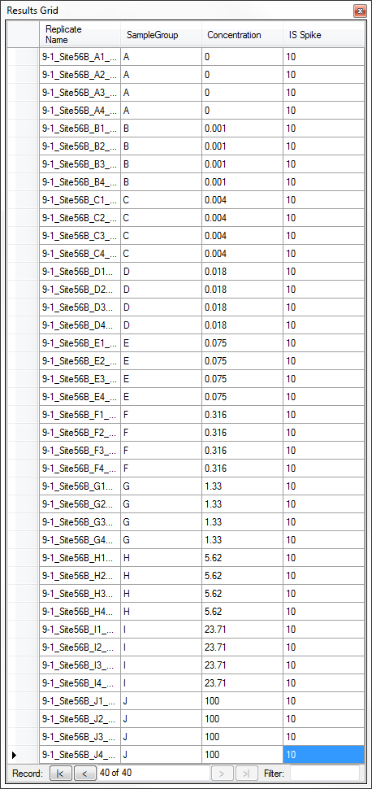

* Close the **Results Grid** in Skyline by clicking the red X in its upper right corner.

# Using QuaSAR

To run a QuaSAR analysis, perform the following steps:

* On the **Tools** menu, click **QuaSAR**.

Skyline will begin exporting the QuaSAR input report. This may take a few minutes. You can track the progress of the report export with the green progress bar in the bottom of the Skyline Window. Once the report is exported, Skyline will display the **QuaSAR** form:

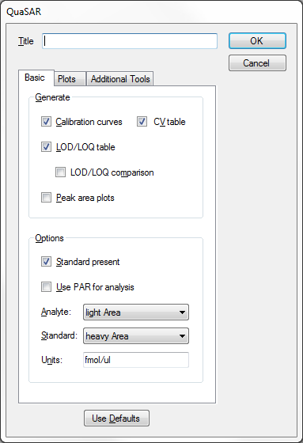

For this tutorial you will leave the options in their default settings. If you wish to learn more about the many options provided by QuaSAR, you can read the documentation [here](ftp://ftp-genome.wi.mit.edu/distribution/genepattern/modules_public_server_doc/QuaSAR_GP_HelpDoc.pdf).

* In the **Title** textbox enter ‘Tutorial’.
* Click the **OK** button on the **QuaSAR** form.

The QuaSAR tool will perform its analysis. The output from the tool run is shown in the **Immediate Window**, the textbox docked at the bottom of the main Skyline window. When the tool is completed, use the Widows explorer to navigate to the directory containing the QuaSAR_Tutorial.sky file. The directory should now contain a number of output files in .csv and .pdf formats generated by QuaSAR, based on the data contained in the Skyline document.